Hero Snake

**Game Play Instructions**

## Background

2088, the Earth are facing a unprecedented famine. Men, women, children and the old are all in hunger. At that time, the savior, Greedy Snake of 1976 appeared. He found that a distant planet, Tisiphone, has a great amount of food. But it's dangerous. To save human beings and all living beings on Earth, he decided to collect food from Tisiphone. There are several dimensions on Tisiphone. And there are tools for him to make it easy.

He must be qualified enough to the next dimension. The more food he eat, the more lives can be saved. You are him.

### Features

1. 1 Player Mode

Hero Snake is a sense of Greedy Snake game. But you can get items at each level. You can read the introduction below for more information.

1. Food 食物

The food is ball-liked. You cannot get to the next level until you get enough food and scores at each level.

1. Axes 开山斧 *D:\CODES\GAMES\Greedy Snake\Debug\images\treasure0.png*

You can get 1~3 axes if you eat this item randomly. One axe can break one block. It’s seems useful at some levels if the food is in a sealed hole.

1. Scissors 命运之剪*D:\CODES\GAMES\Greedy Snake\Debug\images\treasure1.png*

Your one tail will be cut down if you eat this item until you have only a head.

1. Speeder 减速器 *D:\CODES\GAMES\Greedy Snake\Debug\images\treasure2.png*

It’s easy to guess, you will be slower down if you eat this item.

1. Skull 死亡骷髅 *D:\CODES\GAMES\Greedy Snake\Debug\images\treasure3.png*

Stop touching it! It’s dangerous. You will die as soon as you touch it!

1. Bottles 变色瓶 *D:\CODES\GAMES\Greedy Snake\Debug\images\treasure8.pngD:\CODES\GAMES\Greedy Snake\Debug\images\treasure4.pngD:\CODES\GAMES\Greedy Snake\Debug\images\treasure5.pngD:\CODES\GAMES\Greedy Snake\Debug\images\treasure6.pngD:\CODES\GAMES\Greedy Snake\Debug\images\treasure7.png*

You will change your color of body as the item shows and gain certain scores.

1. Door 传送门 *D:\CODES\GAMES\Greedy Snake\Debug\images\door.png*

Congratulations! You can get to the next level through this item.

1. 2 Players Mode

2 players can play at the same time. In this mode, you must choose one map (level) to play. Of cause, you also can make maps (levels) by yourself.

1. Map Editor

We offer a **Map Editor**. Once you made a new map, you must save it to the **/data/ path** and edit the **config.ini** file.

### Interface

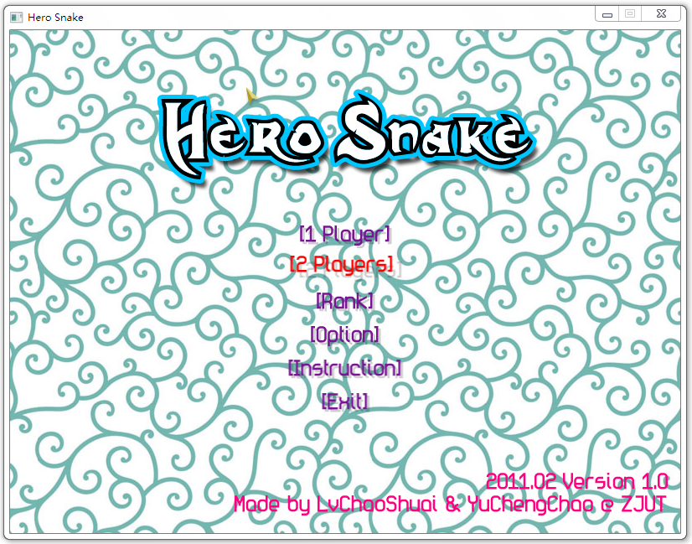

**[3-1] Welcome Screen**

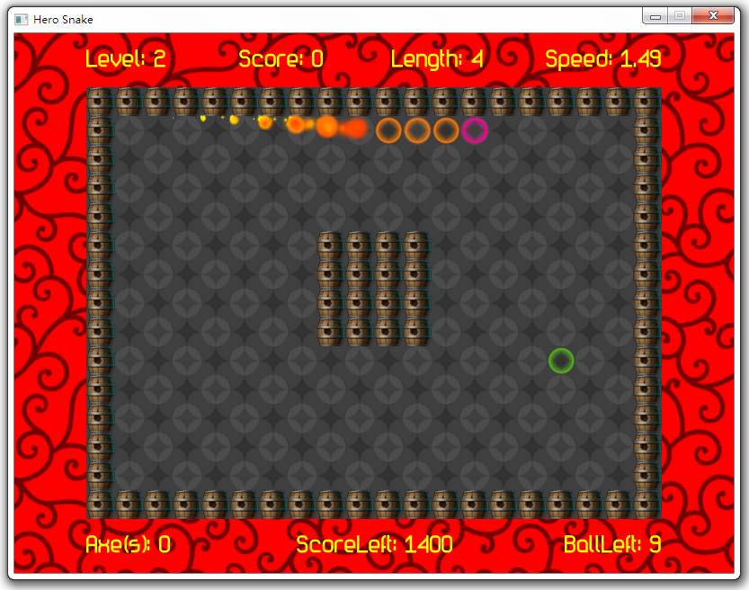

**[3-2] Playing Screen (1 Player Mode)**

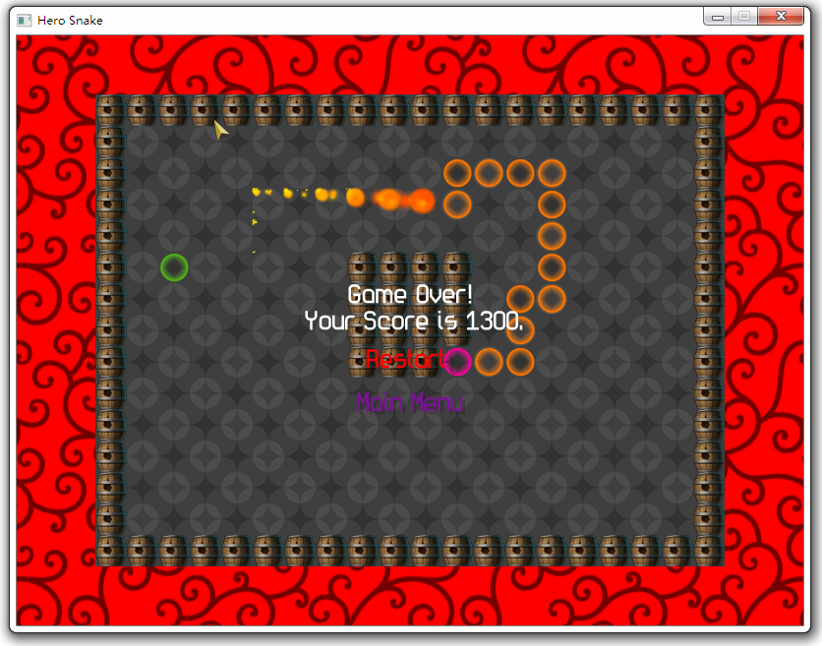

**[3-3] Lose Screen (1 Player Mode)**

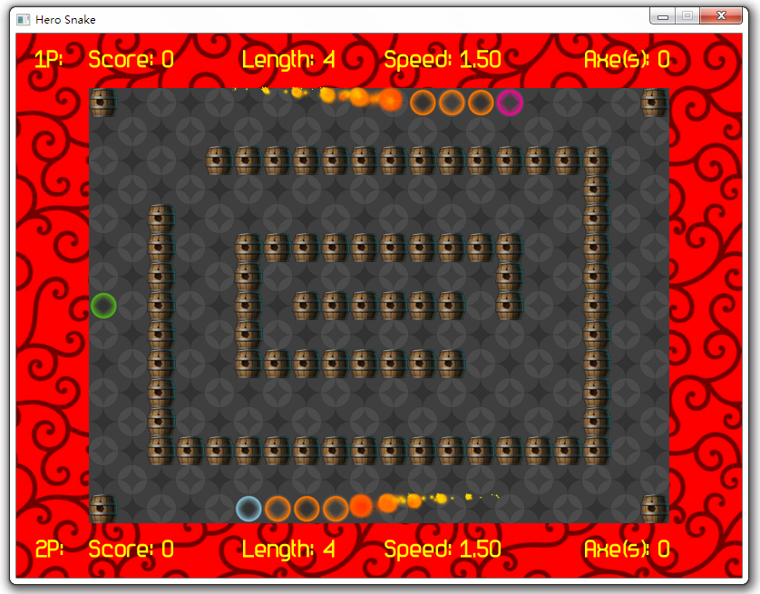

**[3-4] Playing Screen (2 Players Mode)**

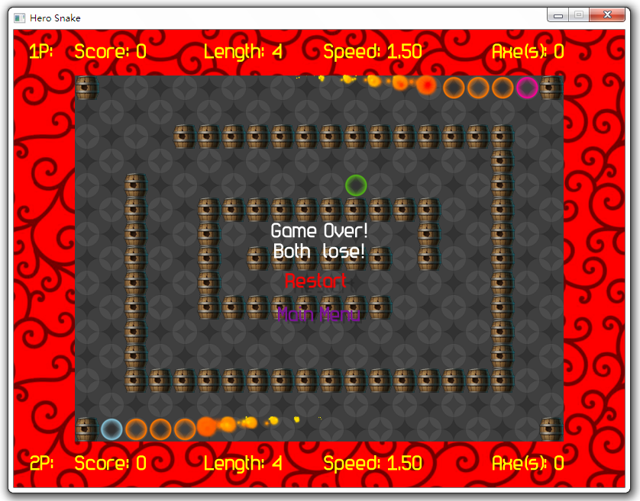

**[3-5] Lose Screen (2 Players Mode)**

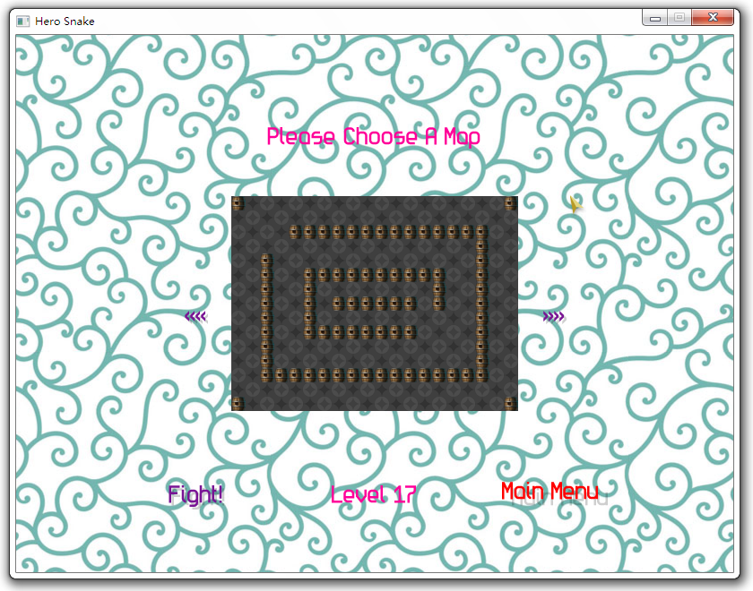

**[3-6] Level Choose Screen (2 Players Mode)**

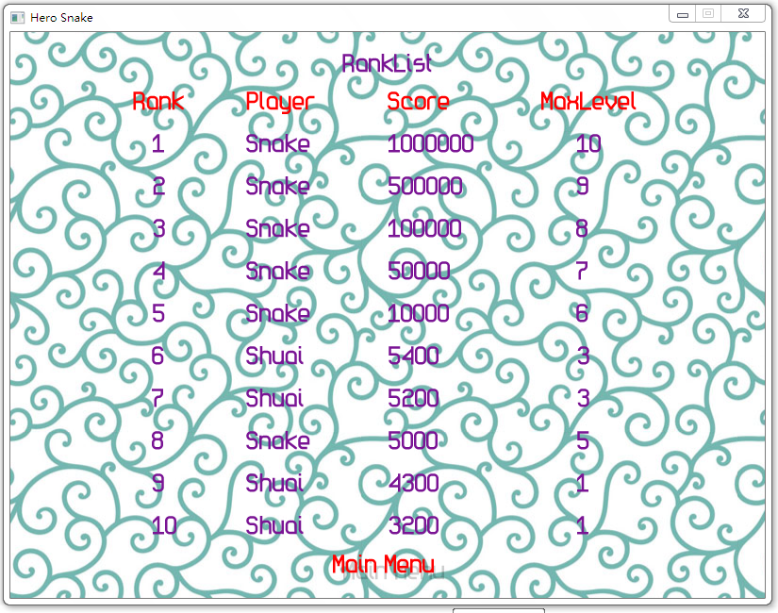

**[3-7] Rank Screen**

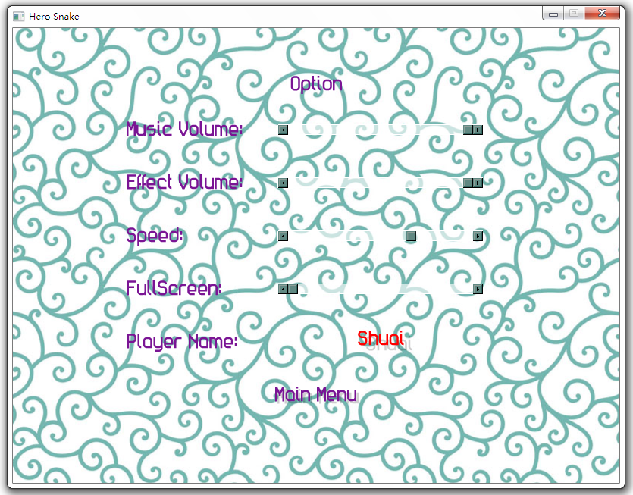

**[3-8] Config Screen**

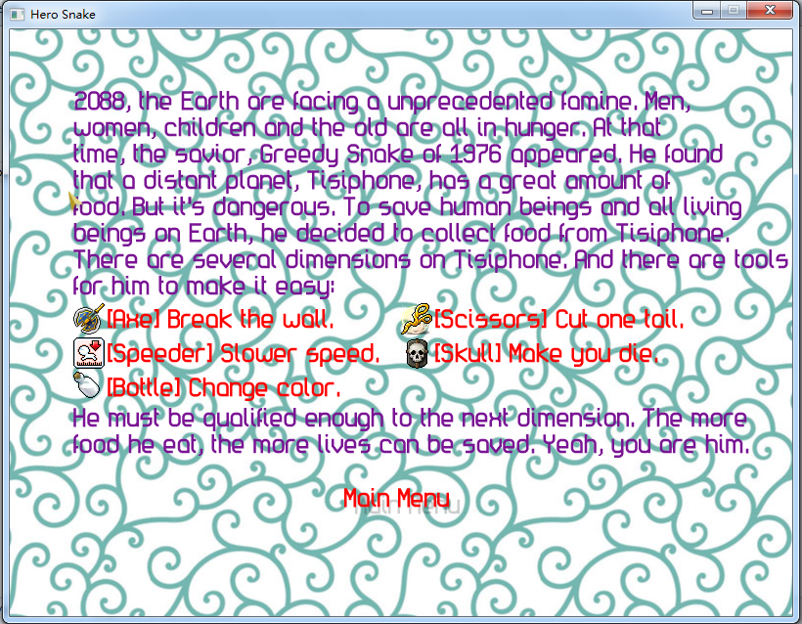

**[3-9] Introduction Screen**

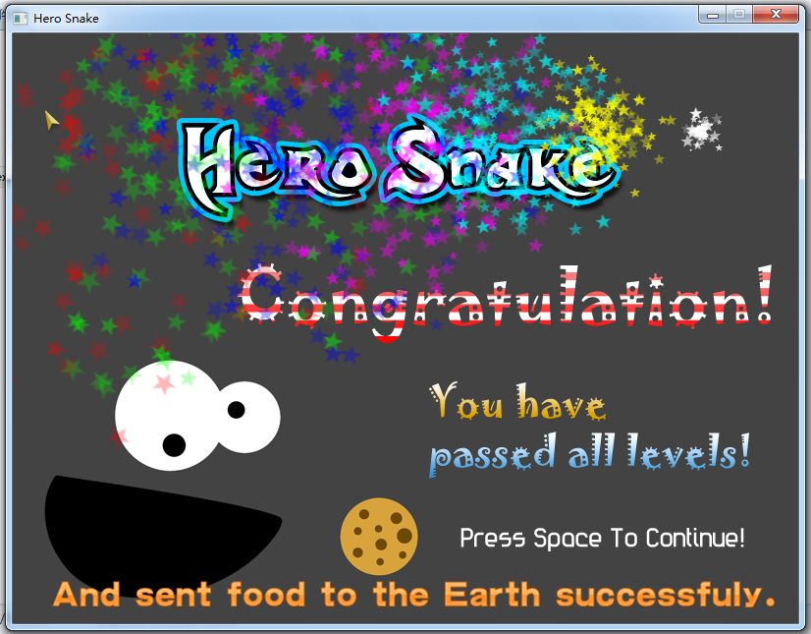

**[3-10] Win Screen (1 Player Mode)**

X2Studio 2011 for ImagineCup